SYSTEM ANALYSIS & DESIGN COMPUTER STUDIES DEPARTMENT

CHAPTER 1

INTRODUCTION

- HISTORICAL BACKGROUND

History of Gat Andres Bonifacio Memorial Medical Center

Gat Andres Bonifacio Memorial Medical Center was established through the vision of Mayor Alfredo S. Lim to provide a hospital for the least fortunate residents of all Six Districts of Manila. By virtue of City Ordinance No. 7947, a 7-storey building was erected at 8001 Delpan Street, Tondo, Manila, District I, at the very heart of the City's most depressed and thickly populated area. This was the 4th hospital in the city build for that purpose. Its catchment area has 137 barangays inclusive of Parola, Smokey Mountain, Recto, Divisoria, Balut, Velasquez and Vitas.

On April 30, 1998, after almost a year of construction, GABMMC opened its doors to its employees and staff for planning and organization. The Out Patient Department was soon opened to the public, later followed by the Emergency Room and Wards, making the hospital fully operational by February 1999.

Year 2004 saw the opening of the Dialysis Unit with 4 machines, which was later expanded to 8 machines. In 2007-2009, the hospital underwent a major renovation of its Wards, the Adult and Pediatric Intensive Care Units, the Operating Room Complex, the Emergency Department, and the 6th floor, and the Diabetic Clinic was opened. From its initial 150 bed capacity, GABMMC has expanded to 250 beds. By 2010, this increase in the number of patients necessitated the construction of a new Out Patient Department (Annex) Building, followed by expansion of the Laboratory Department and Radiology Department with its newly acquired CT Scan Machine, and the opening of the Heart Station with 2D-Echo machine. Last June 28, 2012, the Foot Bridge connecting the two buildings of the hospital was inaugurated.

1 | P a g e

SYSTEM ANALYSIS & DESIGN COMPUTER STUDIES DEPARTMENT

The Admitting and Discharge Section

When GABMMC’s admission of patients started last February 9, 1999, it was headed by Mr. Albert Pacpaco (Records Officer I) as Officer-In-Charge with (5) five personnel namely Ms. Rosalie Lugo, Ms. Jocelyn Quitaleg, Ms. Remedios Cruz-Nening, Mr.

Genesis G. Acuba and Mr. Elmer Jonson.

Presently, Ms. Luzviminda B. Rimando (Administrative Assistant III) is the Officer-InCharge of the Admitting and Discharge Section.

The admitting and discharge section aims to maintain efficient record-keeping for the betterment of patient care, uphold good public relations by proper handling of patients, extending courtesy and good management, and promote health education and serve as source of basic health information.

ADS Mission

To provide an effective Admitting and Discharge service that will ensure efficient admissions, accommodations and discharges of patients and to project a good image to its clients and to the public in general.

ADS Vision

To be a part of the City of Manila’s vision of rendering free medical care within the reach of the less fortunate masses and ensure accurate admissions and discharges of patients.

2 | P a g e

SYSTEM ANALYSIS & DESIGN COMPUTER STUDIES DEPARTMENT

Hospital Leadership of Gat Andres Bonifacio Memorial Medical Center

A. Hospital Directors

1998-2002 | Dr. Ma. Dolores M. Luna
2002-2005 | Dr. Ma. Luisa D. Aquino
2005-2007 | Dr. Rachael P. Marinas
2007-2009 | Dr. Evangeline P. Morales
2009-2011 | Dr. Fidel C. Chua
2011-2012 | Dr. Edwin C. Perez
2012-2012 | Dr. Janet Del Mundo-Tan
2012-2012 | Dr. Marlon P. Millares
2013-2013 | Dr. Karl Oliver B. Laqui
2013-Present | Dr. Ma. Luisa D. Aquino
B. Chief of Clinics
1998-2002 | Dr. Ma. Luisa D. Aquino
2002-2005 | Dr. Arnulfo M. Cornejo
2005-2013 | Dr. Ma. Luisa D. Aquino
C. Administrative Officers
1998-2001 | Mr. Proceso D. Escobar
2001-2007 | Ms. Luzviminda F. Garay
2007-2012 | Mr. Romeo P. De Leon
2012-2012 | Dr. Fresco B. Yapendon
2012-2012 | Mr. Oliver S. Laus
2013-2013 | Ms. Myrna P. Guevarra
D. Chief of Nurses
1998-1999 | Nida Kahulugan, RN
1999-2001 | Emilio Alvarez, RN
2001-2007 | Mary Ann H. Cando, RN
2007-2007 | Ferdinand T. Mapue, RN
2007-2008 | Urduja Iradiel, RN
2008-2009 | Ludivina V. Linezo, RN
2009-2011 | Prescilla A. Eustaquio, RN
2011-2013 | Ludivina V. Linezo, RN

3 | P a g e

SYSTEM ANALYSIS & DESIGN COMPUTER STUDIES DEPARTMENT

GAT ANDRES BONIFACIO MEMORIAL MEDICAL CENTER Organizational Chart – Main Hospital Organization

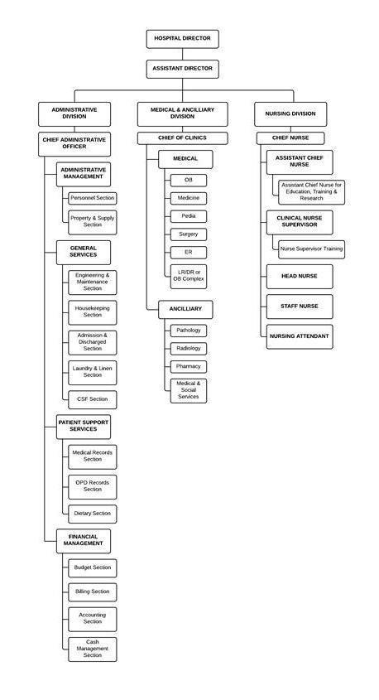

4 | P a g e

SYSTEM ANALYSIS & DESIGN COMPUTER STUDIES DEPARTMENT

GAT ANDRES BONIFACIO MEMORIAL MEDICAL CENTER Organizational Chart – Division under Study

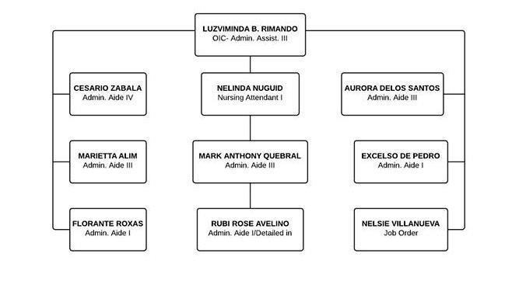

5 | P a g e

SYSTEM ANALYSIS & DESIGN COMPUTER STUDIES DEPARTMENT

- STATEMENT OF THE PROBLEMS

  - Unable to Retrieve Patient’s Medical Record due to his Multiple

Hospital Number Documents Involved

    - Patient Index – a permanent identification card given to newly admitted or consulted patients in the hospital. It is composed of basic information about the patient.

    - Patients Medical Record – also known as the medical chart and hospital record. A systematic documentation of a single patient’s medical history.

Scenario

Patient A proceeds to Admitting and Discharge Section after issuance of Notice of Admission from Emergency Room for an interview and personal verification. The admitting staff will ask if Patient A have already his or her previous consultation to the hospital. Newly admitted patients in the hospital will ensure their permanent patient index, a card containing their basic information. While patients with their previous consultation to the hospital will use their old patient index for it is for lifetime purpose.

If Patient A had its consultation previously and losses its patient index, he or she will again go for new patient index and the admitting staff will ask when his exact last consultation is and if the patient remembers, the hospital will retrieve the hospital number and ask him or her to buy an index card and then the admitting staff will write the retrieved hospital number in the index card. On the other hand, if patient A can no longer remember his last consultation, the admitting staff will give a new index card with new hospital number. The problem is, if Patient A is given a new hospital number, the previous medical record or hospital history will be disregarded because Patient A will have another medical records or hospital history. If the ADS will request for retrieval of medical records they will use the new hospital number but because it is not the original hospital number they can no longer get the previous records from

6 | P a g e

SYSTEM ANALYSIS & DESIGN COMPUTER STUDIES DEPARTMENT

the original hospital number. It can have an impact to his or her diagnosis. Unless, they know and remember their old hospital number.

Causes

  - The Admission Staff cannot monitor if the patient already has his/her previous patient hospital number.

- The Admission Staff can only retrieve the patient’s previous hospital number only if the patient remembers the date of his/her last consultation.

- If cannot be retrieved, the ADS will issue the patient a new patient index.

Impact

- Patient will now having more than one patient index.

- Medical records on the previous hospital number of a patient will be disregarded.

- Important information of their previous consultation cannot be retrieved anymore.

Quantification

Total Patient Admitted in January | 691
Total Patient Admitted in February | 570
Total Patient Admitted in March | 633
Average Patient Admitted Jan-Mar | (691 + 570 + 633) ÷ 3 = 631
Number of Old Patient in January | 85
Number of New Patient in January | 691 – 85 = 606
Number of Old Patient in February | 59
Number of New Patient in February | 570 – 59 = 511
Number of Old Patient in March | 87
Number of New Patient in March | 633 – 87 = 546
Average of Old Patient Jan-Mar | (85 + 59 + 87) ÷ 3 = 77
Average of New Patient Jan-Mar | (606 + 511 + 546) ÷ 3 = 554

As the table shows, only few patients have their old patient index. Those who are new patients, they can be old patients but pretending as newly-admitted patients because they want to be treated immediately. Old patients only

7 | P a g e

SYSTEM ANALYSIS & DESIGN COMPUTER STUDIES DEPARTMENT

composed of 12% of the total admitted patient and new patients fill the 88% of it. It can conclude from the data that almost nine out of ten patients can be old but lost their index therefore, these patient will now occupy another slot for hospital number, which is unique from each other.

Patient will now have multiple identity in the hospital.

- Inability to Determine if the Patient to be Admitted is Absconded or Not Documents Involved

    - Discharge Clearance Slip – given by the "nurses-on-duty" in the nurse's station when a patient is already allowed by the physician to go home serves as clearance for all the transaction in the hospital; presented lastly in the Admitting and Discharge Section.

  - Discharge Slip – given by the admitting and discharge section in exchange of accomplished Discharge Clearance Slip; presented to the security guard before a patient can leave the hospital; serves as a gate pass.

  - Record of Admission – list of large number of patients admitted or having consultation. It includes the date of their last consultation, hospital number, complete name of patient, sex, age, address, Admitting Diagnosis/Physician, P.T Member, Discharged Diagnosis, Attending Physician and Length of Stay.

  - Summary of Discharge – it include everything noted about your stay, diagnosis, test results, and medications, as well as your condition when you left the hospital.

Scenario

When Patient A does not have enough money for the payments in the hospital, they tend to escape without authority or completion of clearance and without paying. The hospital cannot recognize them because they do not have records of the absconded patients’ identities in ADS. Since ADS and ER can’t monitor previous discharge status of every patients the absconded patients will be re-consulted and re-admitted again because the hospital can no longer identify

8 | P a g e

SYSTEM ANALYSIS & DESIGN COMPUTER STUDIES DEPARTMENT

those patients. They only know the number of patients who escaped but not their names so the hospital cannot take necessary actions about their previous escape. Escape of patients will also affect the income of the hospital because when a patient leaves, the hospital can no longer ask them to pay.

Causes

  - The Admitting and Discharge Section only signifies the total number of absconded patients and not their profiles.

- The Admitting and Discharge Section doesn’t have a record of the profiles of the absconded patients.

Impact

- Absconded patients can be admitted again in the hospital without knowing by the Admitting and Discharge Section.

- The hospital will be incapable of developing their services due to lack of funds.

Quantifications

Total Absconded Patients in January | 14
Total Paid Patients in January | 634
Total Absconded Patients in February | 8
Total Paid Patients in February | 613
Total Absconded Patients in March | 7
Total Paid Patients in March | 601
Average Absconded Patient Jan-Mar | (14 + 8 + 7) ÷ 3 = 10
Total Cost in Pharmacy In-Patients for | P 912,825.08
the month of January
Total Patients Served in Pharmacy for | 634
the month of January
Average Cost per Patient in January | 912,825.08 ÷ 634 = 1,439.79
Total Cost in Pharmacy In-Patients for | P 1,087,405.54
the month of February
Total Patients Served in Pharmacy for | 613
the month of February
Average Cost per Patient in February | 1,087,405.54 ÷ 613 = 1,773.91

9 | P a g e

SYSTEM ANALYSIS & DESIGN COMPUTER STUDIES DEPARTMENT

Total Cost in Pharmacy In-Patients for | P 727,530.92
the month of March
Total Patients Served in Pharmacy for | 601
the month of March
Average Cost per Patient in March | 727,530.92 ÷ 601 = 1,210.53
Average Cost per Patient from the | (1,439.79 + 1,773.91 + 1,210.54) ÷ 3 =
month of January to March | P 1,474.75
Average Loss of Income Jan-Mar | 1,474.75 * 10 = P 14,747.53

The Pharmaceutical Department is one of the most paid department of the hospital. Large cost of transaction happens here. Even the number of absconded patients is not that alarming, but the hospital can experience a loss of income due to this instances. With the P 14,747.53 average cost per month, the hospital can lost about one hundred fifty thousand pesos per year.

3. The ADS Cannot Immediately Receive Notifications from the Wards for the Available Rooms and Beds

Documents Involved

- Patients Directory - list of patients that includes their name, room number and their designated physician.

Scenario

After Patient finishes all the pre-admitting processes, the ADS Staff will have to `contact the respective Ward Nurse-on-Duty through the telephone for the checking the available rooms/beds. While checking for available rooms/beds, Patient A will wait in the Emergency Room.

There are cases that the current Nurse-on-Duty was not properly advised by the previous Nurse-on-Duty about the rooms, those are soon to be vacant yet still in the process. As a result, the present Nurse-on-Duty will still consider it as vacant. When there is a sudden change in the discharge of Patient A, like for instance that he/she should stay for a longer time because of unexpected changes in his/her condition, but the ADS considered him/her in the process

10 | P a g e

SYSTEM ANALYSIS & DESIGN COMPUTER STUDIES DEPARTMENT

for discharge, there can occur discrepancy in the records of the ADS and Ward Nurse-on-Duty.

Also when the current Nurse-on-Duty was not properly advised about the need to update the ADS about the availability of bed or room, there can be delay of admitting patients.

Causes

  - The Patient Directory was only located in the designated wards and the only way to inform the ADS is via telephone.

- The nurse on the next shift was not properly informed by the nurse on the previous shift in their respective wards.

- The ADS was not informed about the status of postponed discharge of patient by the physician due to sudden change of his/her condition.

Impact

- Delay in admitting the patient to their respective wards.

- Discrepancy in the number of discharge in ADS to the ward.

Quantification

Total Patient Admitted in January | 691
Total Patient Admitted in February | 570
Total Patient Admitted in March | 633
Average Patient Admitted Jan-Mar | (691 + 570 + 633) ÷ 3 = 631
Average Patient Admitted per Day | 631 ÷ 31 = 20
Average Length of Stay | 5 Days
Total Capacity of ER (1st Floor) | 25 Beds x 2 Patients = 50
Total Capacity of OB Ward (3rd Floor) | 10 Rooms x 5 Beds x 2 Patients = 100
Total Capacity of Pediatric (4th Floor) | 8 Rooms x 5 Beds x 2 Patients = 80
Total Capacity of PICU (4th Floor) | 1 Room x 6 Cribs x 1 Patient = 6
Total Capacity of Medicine (5th Floor) | 13 Rooms x 3 Beds x 1 Patient = 39
Total Capacity of MICU (5th Floor) | 1 Room x 6 Beds x 1 Patient = 6

11 | P a g e

SYSTEM ANALYSIS & DESIGN COMPUTER STUDIES DEPARTMENT

As the table shows, not only the ADS will have a problem in monitoring of beds, also in the respective wards the problem will occur due to large capacity and large number of patient that admitted in the hospital. Also, discrepancy in the records in the Patient Directory is inevitable. From time to time, the ADS will have to call for the available rooms to the respective wards for the average of twenty patients per day. Admitting a patient will consume for about 20 minutes so since there is difficulty in monitoring, it also contributes to the time for the ADS file up an admitting patient

- Discrepancy of Reports Generated Documents Involved

  - Record of Admission – list of large number of patients admitted or having consultation. It includes the date of their last consultation, hospital number, complete name of patient, sex, age, address, Admitting Diagnosis/Physician, P.T Member, Discharged Diagnosis, Attending Physician and Length of Stay.

  - Midnight Census – created and held between 10pm to 6 am by the nurse/s

Scenario

Every first week of the month, the admitting staffs collect all the 24 hour census of the previous month to create their monthly census. The admitting staffs also use the Record of Admission as a basis in creating the census.

The admitting staffs computes for the total number patients served in the respective wards. They scan through the diagnosis and physician from the Record of Admission to know if the patient is in obstetrics, medicine, surgery, pediatrics, gynecology, ENT, ophthalmology, NICU or rooming-in and write it down on their census. The staffs will then compute for the monthly reports which include the midnight census held between 10pm to 6am. The admitting staffs will also classify then compute the number of admitted patients whether they are Manilans or Non Manilans. They also computes the outcome of

12 | P a g e

SYSTEM ANALYSIS & DESIGN COMPUTER STUDIES DEPARTMENT

patients treatment whether it is HAMA, Absconded, transferred, mortality, unimproved, recovered/ improved.

Also the admitting staffs compute for the number of admitted and discharged patients per month. There are cases that the number of admitted per month is greater than the discharged and vice versa. When the number of admitted patients is greater than the discharged, the hospital may assume that they are absconded. While in cases where the discharged patients is greater than the admitted, discrepancy may be assumed.

Cause

- Patients may suffer sudden change of his or her condition.

- Some patients that are admitted on the current month might be discharged in the next month.

Impact

- Some patients are considered discharge in Ward sections but not yet in Admitting and discharge Section.

- The number of admitted patients is not equal to the number of discharge patients.

Quantification

Number of in-charge in making | 1 staff
midnight census
Time it takes to get the data in every | 15 minutes
ER Blotter Sheet
Total time it takes to get the data in | 15 * 30 = 450 minutes
every ER Blotter Sheet in a Month
Time it takes to get the number of | 5 minutes
admitted patients from the record of
admission
Time it takes to get the number of | 5 minutes
discharge patients from the record
of admission
Hours per day allotted to do midnight | 1 hour
census

13 | P a g e

SYSTEM ANALYSIS & DESIGN COMPUTER STUDIES DEPARTMENT

Time it takes to get the total number | 1 hour
of patients
Time it takes to finish the report | 2 hours

14 | P a g e

SYSTEM ANALYSIS & DESIGN COMPUTER STUDIES DEPARTMENT

IV. SCOPE AND LIMITATIONS

This study focuses on the Admitting and Discharge Section of Gat Andres Bonifacio Memorial Medical Center. It includes admissions, accommodations, retrieving of records of admitted patients and discharging procedures of patients. The study aims to improve the record keeping of patients who are admitted, proper handling of patients starting from interviews, room assignments up to their discharge. The study will not include the ER Consultation and Out-Patient Department Consultation.

15 | P a g e

